**Introduction to Computer Science Fall 2018: Final Project**

**Game Name**: F1 Abu Dhabi (F1 AD)

**Game Developers**: Sahil Maisuria and Prabhav Arora

**How to Run the game:**

Clone using ‘git clone’ by entering the link provided on the website on the git bash terminal or zip all the contents into a folder and download onto your desktop. Extract all the contents and open the folder. Next, open the ‘F1_AD’ folder and search for ‘F1_AD.pyde’ file. Run the game by double clicking on F1_AD.pyde and clicking on the 'play' symbol to run the game once the processing app is open.

**Purpose of the game:**

The main purpose of the game is to test the user’s hand-eye coordination and reflexes along with the ability to score the highest points possible in a competitive environment situated within an arcade styled atmosphere.

**Game Description:**

The game was inspired by the mechanics from the mobile game: "Subway Surfers" and other retro -arcade, top-down, side-scrolling racing games where the user has to score the highest points possible. The velocity of all assets (user car and enemy car) increases by a tiny amount that creates the illusion that the objects on the game have become faster as you progress further into the game. The game sprites and backgrounds have been downloaded from various websites for free and were modified to suite the game style using Adobe Photoshop. The frames for various game objects were replicated by placing each image object side-by-side with an equal distance between them. The game sounds had also been downloaded from various websites for free and modified to adjust the game style using Adobe Audition.

The first objective of the development of this game was to modify and extract all the assets from sprite sheets and place them into .png or .jpg images. Next was setting out the mechanics and overall coding style. The structure of the code follows a parent-child class pattern (Inheritance), in which the child classes have modified attributes and methods (polymorphism). The main mechanics of the game include the velocity function, collision detection, shields, coin and power-up collection. The velocity function works by increasing the ‘x’ velocity by 0.003 every frame for the f1Car and increasing the enemy cars’ velocity by gradual amounts. The power up within the game adds a protective layer to the car and changes the shield state to true. The game functions by using the right arrow-key to initiate the first launch of the car, and the up and down keys move the F1car across the various lanes. Upper and lower bounds were placed by checking the relative position of the user’s car and updating it back on the screen by a small amount.

**Screenshots:**

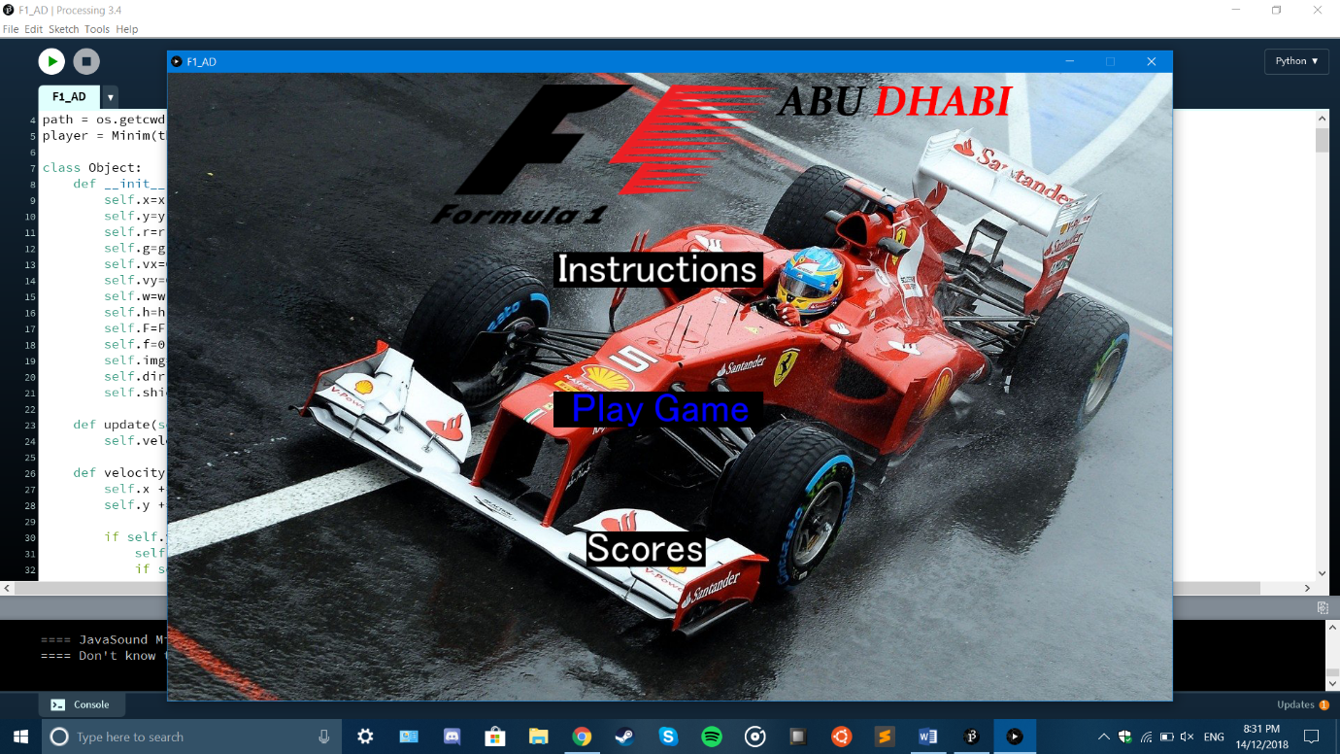

*The main menu for F1 AD.*

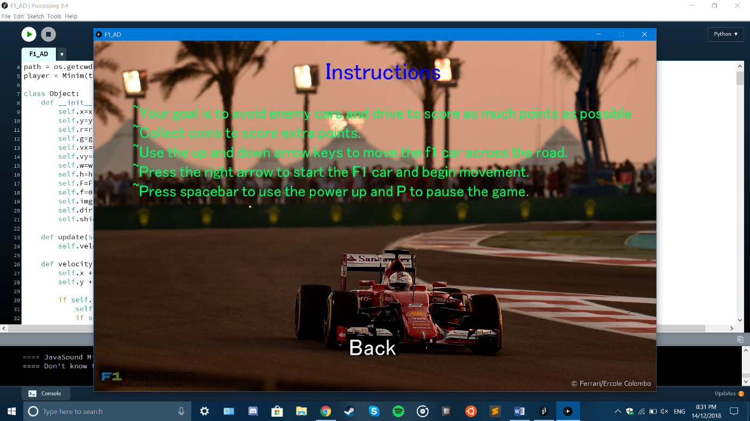

*The game instructions panel displaying the objective of the game and movement controls.*

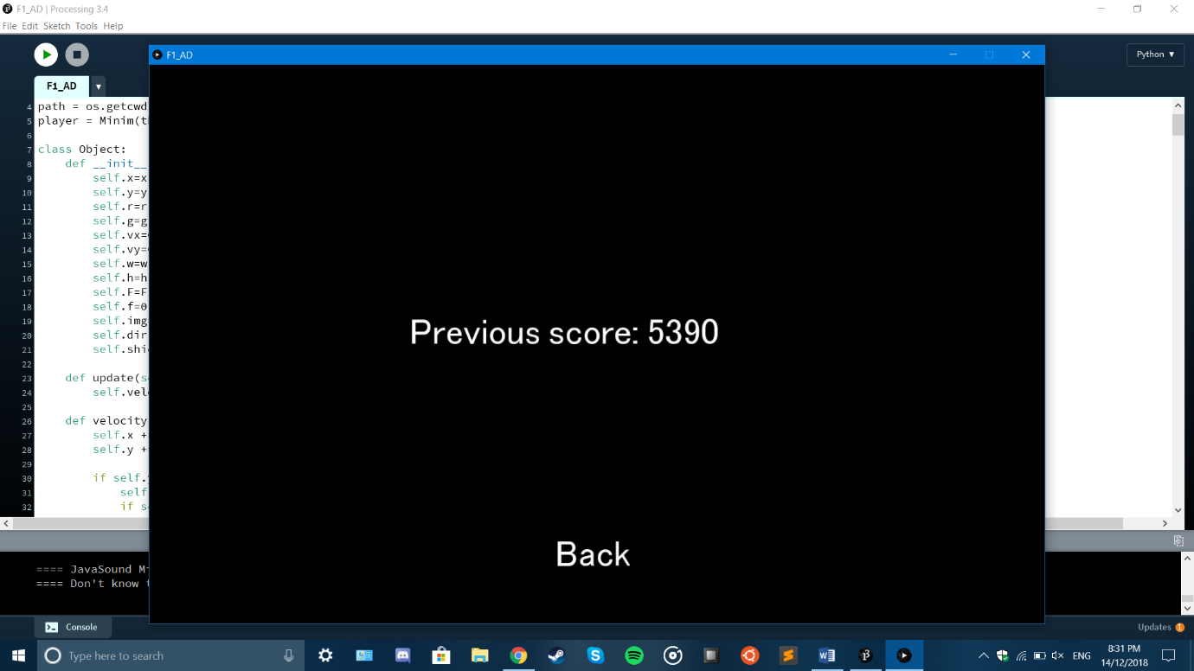

*The scores panel for the game that displays the previous score earned in the game which is the last line of the text file.*

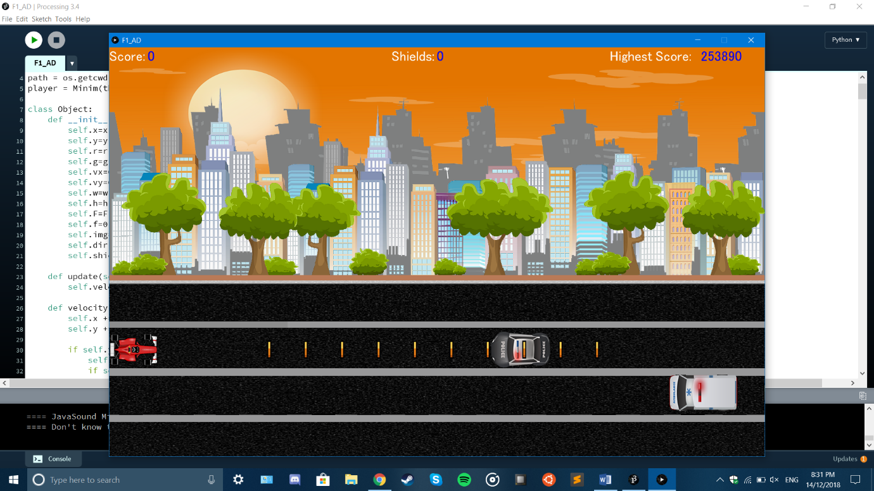

*Initial start of the game displaying the user’s car, background, enemy cars, coins, game score, number of shields and the highest score. The user always spawns at a fixed location.*

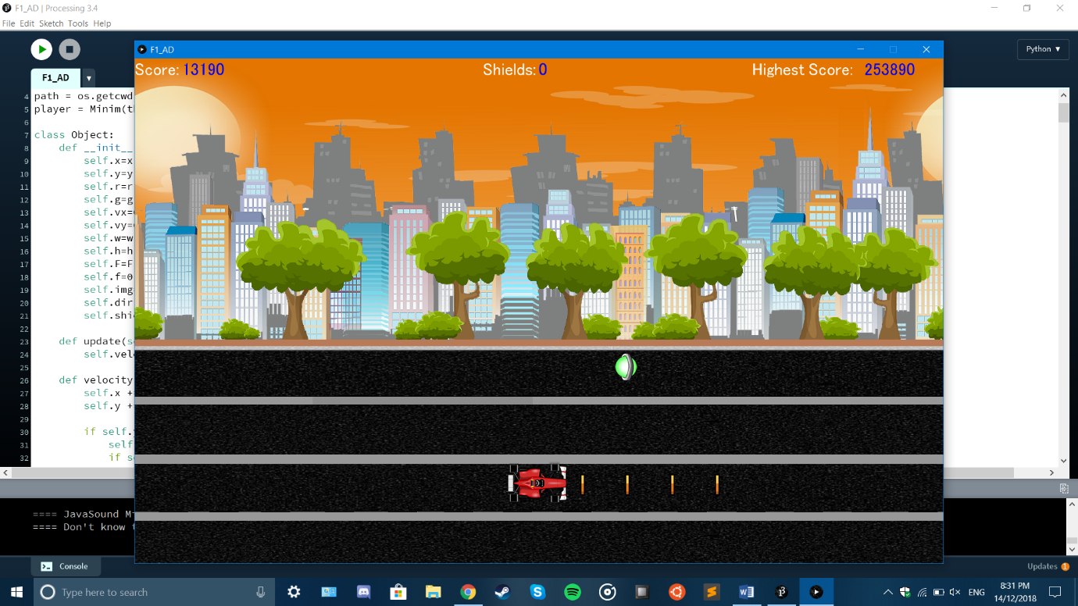

*Driving and avoiding enemies accumulates points and upon coin collection, the user gets 1000 points for each coin.*

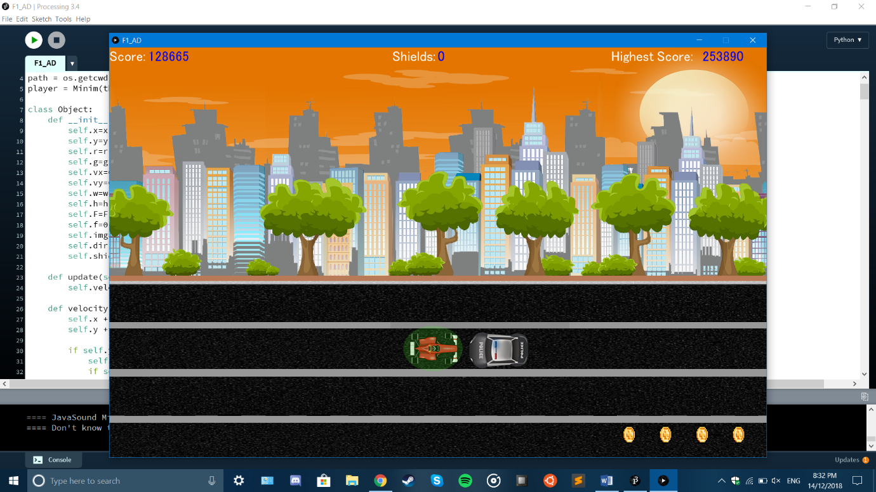

*Obtaining a powerup and pressing the ‘spacebar’ changes the state of the car and adds a protective layer that only diminishes upon enemy collision.*

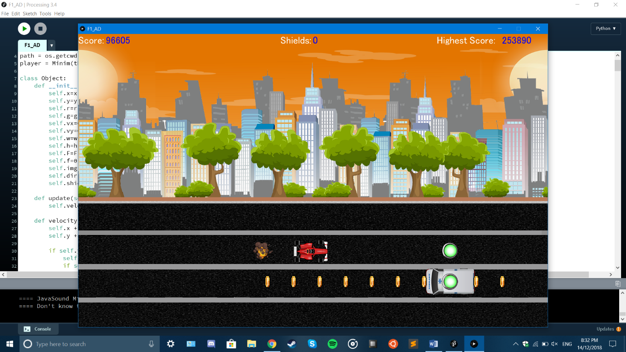

*The shield adds a protective layer to the car that explodes and destroys enemy cars upon collision leaving the user’s car untouched.*

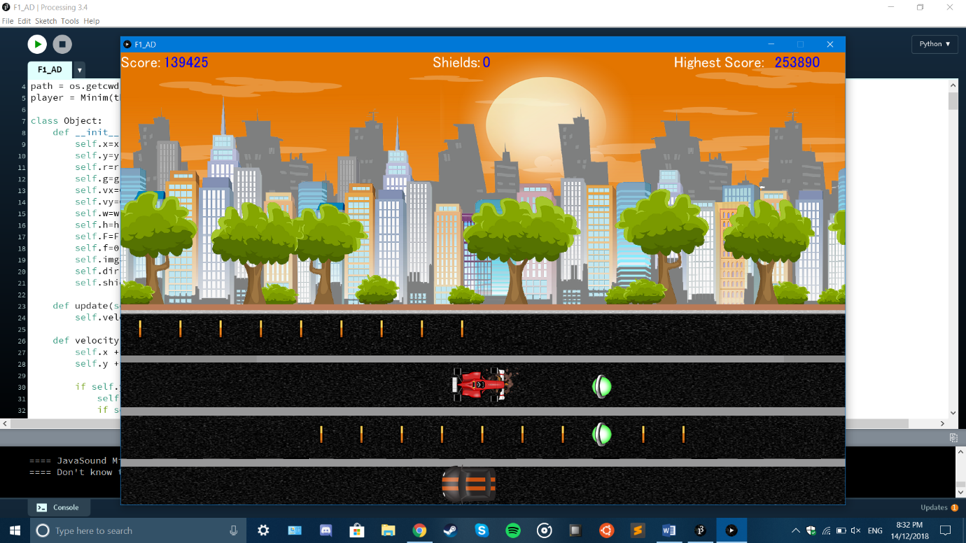

*Colliding with an enemy without a shield changes the game state to lose and sets x velocity to zero and initializes a new game with the previous score appended to a text file.*